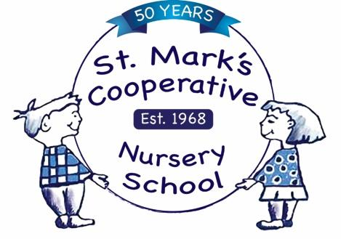
St. Mark’s Cooperative Nursery School

100 Hempstead Avenue ∗ Rockville Centre, New York ∗ 11570
(516) 536-6295 ∗ Fax (516) 763-5141

FORM #1 - EMERGENCY TREATMENT PERMISSION

CHILD’S NAME:_____________________________________________________________________________

DOES YOUR CHILD HAVE ALLERGES TO ANY FOOD OR MEDICINE?____________________________________
PEDIATRICIAN NAME AND PHONE #: ___________________________________________________________
PRIMARY ADDRESS: _________________________________________________________________________
__________________________________________________________________________________________

PARENT #1 NAME: ______________________________ PRIMARY PHONE #:________________________

PARENT #2 NAME#: ______________________________ PRIMARY PHONE #:_________________________

Primary Daytime Contact Name:_______________________________________________________________

Relation to Child: _______________________________________________________________

Phone During School Hours: _ ____________________________________________________

If neither parent or daytime caregiver can be reached in the event of an emergency, the next person to call is:

EMERGENCY CONTACT NAME_________________________________________________________________
(Other than Parent)

RELATIONSHIP TO CHILD: ____________________________________________________________________

PHONE: _____________________________________ CELL PHONE#: _________________________

If my child should require medical attention due to accident or illness during school hours, and neither parent nor the family doctor can be reached, I hereby give my permission to have emergency treatment administered by any physician available to the school.

PARENT’S SIGNATURE________________________________________________________________

